SIR CHHOTU RAM INSTITUTE OF
ENGINEERING & TECHNOLOGY


Practical File
on
Web Designing

Branch – Computer Science / 3rd Semester
Session: 2023 - 2024

––––––

Submitted By:
Naam aayega idhr
Roll no. 100200300
Submitted To:
Idhr Teacher ka naam

Table of Contents
S.no | Content
1. | Create a web page using Anchor tag with its attributes for external links.
2. | Create a web page, showing an ordered list of all second semester courses
3. | Create a web page, showing an unordered list of names of all the Programs (Branches) in your institution.
4. | Create links on the words e.g. ―Wi-Fi and ―LAN‖ to link them to Wikipedia pages.
5. | Embed Audio and Video into your HTML web page.
6. | Insert an image and create a link such that clicking on image takes user to other page.
7. | WAP in html to design a Bio-Data
8. | Create table in HTML with Dummy Data
9. | WAP in html to create a webpage to show different hobbies.
10. | WAP in html to create a webpage with four frames (Picture, table, list, and hyperlink).

- Create a web page using Anchor tag with its attributes for external links.

<html>
<head>
<title>Practical 1</title>
</head>
<body>
<h1>Practical 1 Using Anchor Tags to link to external website</h1>
<div style="display: flex; flex-direction: column;">
<a href="https://www.example.com" target="_blank">
Visit Google
</a>
<a href="https://www.example.com" target="_blank">
Visit Facebook
</a>
<a href="https://www.example.com" target="_blank">
Visit Instagram
</a>
<a href="https://www.example.com" target="_blank">
Visit devangspsingh.github.io
</a>
</div>
</body>
</html>

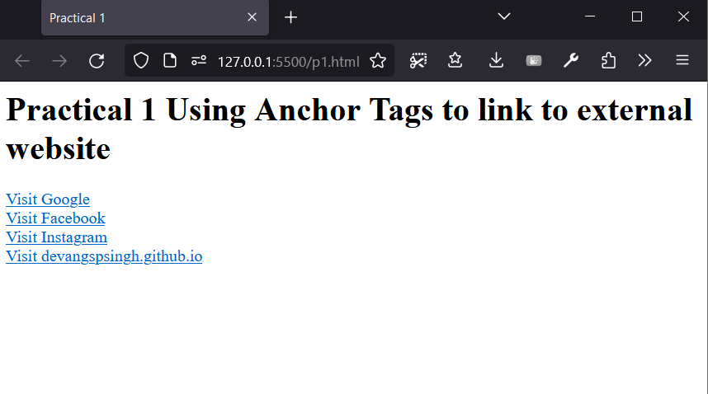

- Create a web page, showing an ordered list of all second semester courses.

<html>
<head>
<title>Second Semester Courses</title>
</head>
<body>
<h1>Second Semester Courses</h1>
<ol>
<li>Course 1 Web Design</li>
<li>Course 2 Data Structures</li>
<li>Course 3 COA</li>
<li>Course 4 Discrete Structures and Thoery of Logic</li>
<li>Course 5 Digital Electronics</li>
</ol>
</body>

</html>

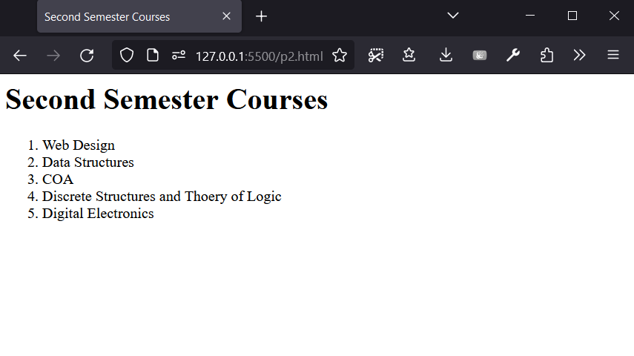

- Create a web page, showing an unordered list of names of all the Programmes (Branches) in your institution.

<html>
<head>
<title>Programmes in Institution</title>
</head>
<body>
<h1>Programmes in Institution</h1>
<ul>
<li>B.Tech</li>
<li>M.Tech</li>
<li>B.Sc</li>
<li>B.Pharma</li>
</ul>
</body>
</html>

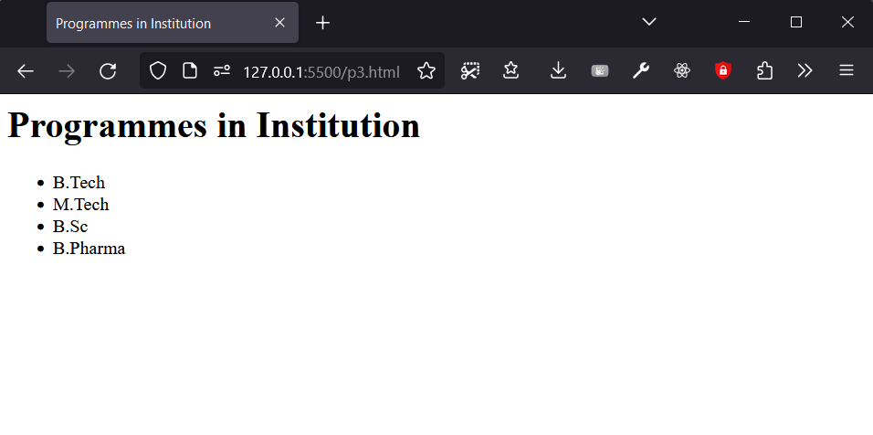

- Create links on the words e.g. ―Wi-Fi and ―LAN‖ to link them to Wikipedia pages.

<html>
<head>
<title>Wifi</title>
</head>
<body>
<h1>More about Wifi</h1>
<p>
<a href="https://en.wikipedia.org/wiki/Wi-Fi"> WiFi</a>
is a wireless networking technology that allows devices to
connect to the internet or communicate with eachother without the need for wired connections.
</p>
</body>
</html>

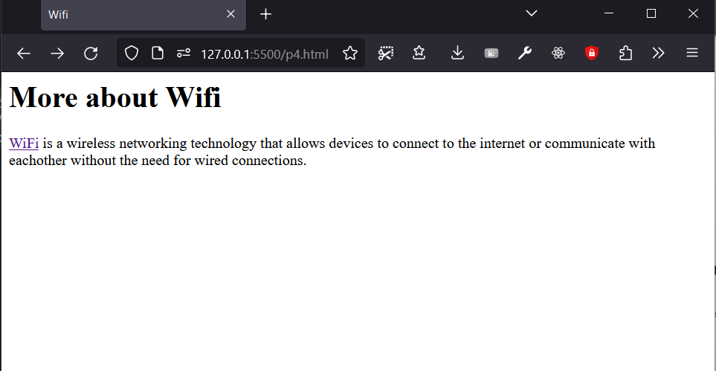

- . Embed Audio and Video into your HTML web page.

<html>
<head>
<title>Media</title>
</head>
<body>
<h1>Media</h1>

<div>
<h2>Audio Example</h2>
<audio controls>
<source src="https://example.com/audio.mp3" type="audio/mpeg">

Your browser does not support the audio element.
</audio>

</div>

<div>
<h2>Video Example</h2>
<video controls width="400px">

<source src="https://storage.googleapis.com/gtv-videos-bucket/sample/BigBuckBunny.mp4" type="video/mp4">

Your browser does not support the video element.

</video>
</div>

</body>
</html>

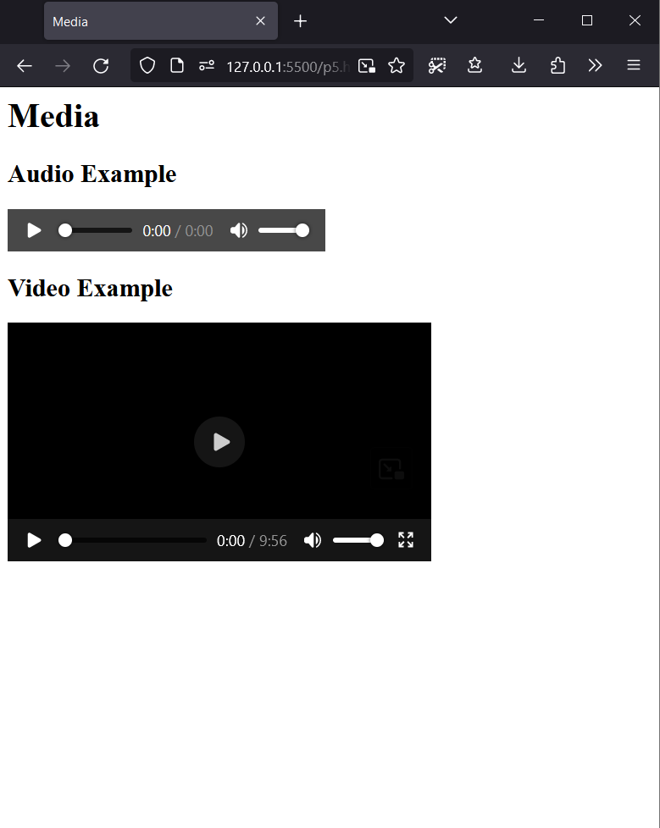

- Insert an image and create a link such that clicking on image takes user to other page.

<html>
<head>
<title>Image</title>
</head>
<body>
<h1>Image</h1>

<div>
<h2>Image Insertion</h2>

<a href="https://devangspsingh.github.io">
<img src="https://devangspsingh.github.io/assets/main.80e4f85a.png" alt="Image" width=”500px”>
</a>
</div>

</body>
</html>

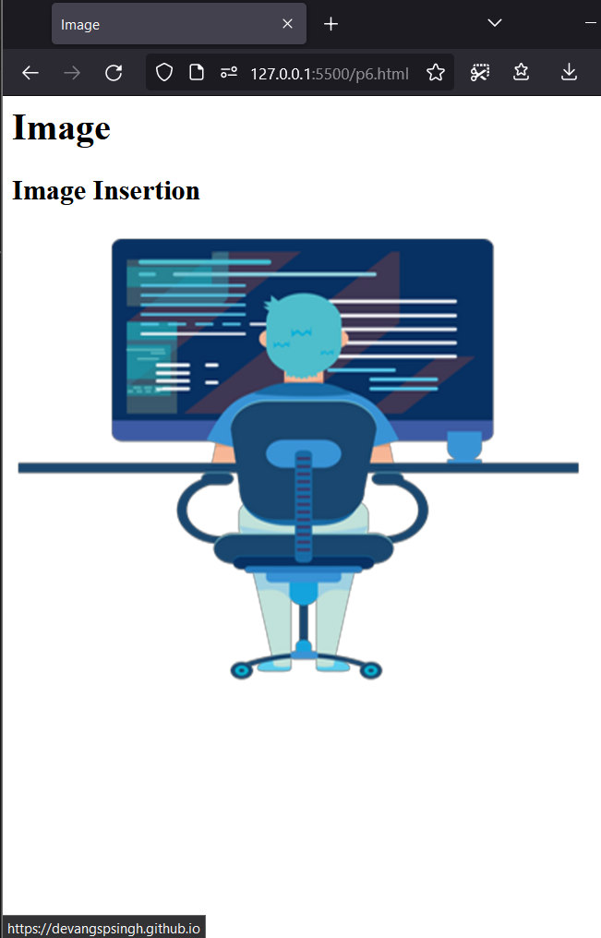
- Insert an image and create a link such that clicking on image takes user to other page.

<html>
<head>
<title>Bio-Data</title>
<style>
body {
font-family: Arial, sans-serif;
}
h1 {
text-align: center;
}
.personal-info {
margin-bottom: 20px;
}
.personal-info p {
margin: 5px 0;
}
.education {
margin-bottom: 20px;
}
.education h3 {
margin-bottom: 5px;
}
.skills {
margin-bottom: 20px;
}
.skills ul {
list-style-type: none;
padding: 0;
}
.skills li {
margin-bottom: 5px;
}
</style>
</head>
<body>
<h1>Bio-Data</h1>

<div class="personal-info">
<h2>Personal Information</h2>
<p>Name: Chaman Prash</p>
<p>Date of Birth: January 1, 1990</p>
<p>Address: SCRIET MEERUT</p>
<p>Email: Chaman@prash@example.com</p>
<p>Phone: 123-456-7890</p>
</div>

<div class="education">
<h2>Education</h2>
<h3>AALO TECH UNIVERSITY</h3>
<p>Course: Bachelor of Science</p>
<p>Year of Completion: 2022</p>
</div>

<div class="skills">
<h2>Skills</h2>
<ul>
<li>HTML</li>
<li>CSS</li>
<li>JavaScript</li>
<li>Python</li>
</ul>
</div>
</body>
</html>

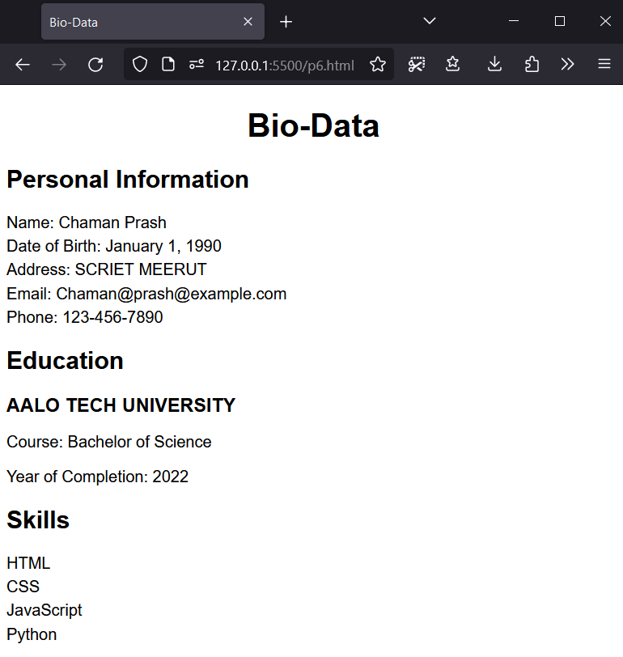

- Create a table ion html with dummy data.

<html>
<head>
<title>Student Record</title>
</head>
<style>
table {
width: 100%;
border-collapse: collapse;
}

th, td {
padding: 8px;
text-align: left;
border-bottom: 1px solid #ddd;
}

th {
background-color: #f2f2f2;
}

tr:hover {
background-color: #f5f5f5;
}

</style>
<body>
<h1>Student Record</h1>
<table>
<tr>
<th>Registration No</th>
<th>Student Name</th>
<th>Year Semester</th>
<th>Date of Admission</th>
</tr>
<tr>
<td>67890</td>
<td>Chota Bheem</td>
<td>2022 - Semester 1</td>
<td>2022-02-01</td>
</tr>
<tr>
<td>98765</td>
<td>Doraemon</td>
<td>2022 - Semester 1</td>
<td>2022-02-15</td>
</tr>
<tr>
<td>24680</td>
<td>Ninja Hattori</td>
<td>2022 - Semester 1</td>
<td>2022-03-01</td>
</tr>
</table>
</body>
</html>

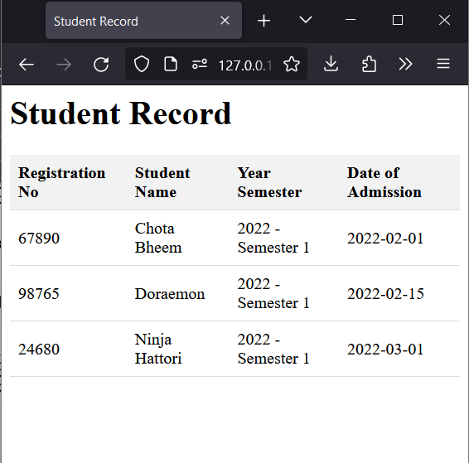
- WAP in html to create a webpage to show different hobbies..

<html>
<head>
<title>My Hobbies</title>
<style>
.card {
display: inline-block;
width: 200px;
border: 1px solid #ccc;
border-radius: 5px;
padding: 10px;
margin: 10px;
}
.card img {
width: 200px;
height: 100px;
}
</style>
</head>
<body>
<h1>My Hobbies</h1>

<div class="card">
<h3>Playing cricket</h3>
<p>A fun sport played with a bat and ball.</p>
<img src="cricket.jpeg" alt="Hobby 1">
</div>

<div class="card">
<h3>Playing football</h3>
<p>A popular team sport played with a ball.</p>
<img src="football.jpeg" alt="Hobby 2">
</div>

<div class="card">
<h3>Coding</h3>
<p>You should know it if you want to be my friend.</p>
<img src="coding.jpeg" alt="Hobby 3">
</div>

</body>
</html>

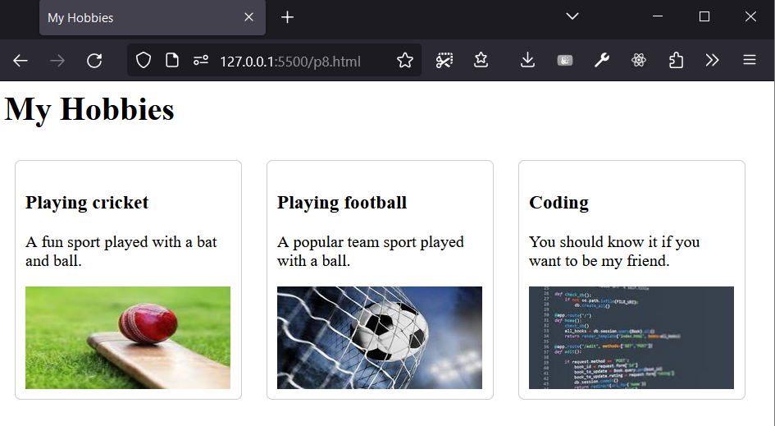

- WAP in html to create a webpage with four frames (Picture, table, list, and hyperlink).

<html>

<head>
<title>Webpage with Frames</title>
</head>

<style>
.container {
display: flex;
flex-wrap: wrap;
gap: 10px;
justify-content: center;
}

.frame {
min-width: 400px;
border-radius: 20px;
padding: 20px;
border: 2px;
border-style: solid;
}

table {
width: 100%;
border-collapse: collapse;
margin-bottom: 20px;
}

h2 {
font-family: Arial, sans-serif;
font-size: 20px;
color: #333;
}

th,
td {
padding: 10px;
text-align: left;
border: 1px solid black;
}

th {
background-color: #f2f2f2;
}
</style>

<body>
<h1 style="text-align: center;">Hobbies of mine</h1>
<main class="container">
<section class="frame">
<h2>As an image</h2>
<img src="coding.jpeg" alt="coding image" width="200px" height="200px">
<img src="cricket.jpeg" alt="cricket image" width="200px" height="200px">
</section>

<section class="frame">
<h2>As a table</h2>
<table>
<tr>
<th>Serial Number</th>
<th>Title</th>
<th>How much I love it</th>
</tr>
<tr>
<td>1</td>
<td>Coding</td>
<td>⭐⭐⭐⭐⭐</td>
</tr>
<tr>
<td>2</td>
<td>Reading</td>
<td>⭐⭐⭐</td>
</tr>
<tr>
<td>3</td>
<td>Playing Guitar</td>
<td>⭐⭐⭐⭐</td>
</tr>
</table>
</section>

<section class="frame">
<h2>As a list</h2>
<ul>
<li>Coding</li>
<li>Reading</li>
<li>Playing Guitar</li>
<li>Swimming</li>
<li>Hiking</li>
</ul>
</section>

<section class="frame">
<h2>As hyperlinks</h2>
<ul>
<li><a href="https://en.wikipedia.org/wiki/Coding">Coding</a></li>
<li><a href="https://en.wikipedia.org/wiki/Reading">Reading</a></li>
<li><a href="https://en.wikipedia.org/wiki/Playing_guitar">Playing Guitar</a></li>
<li><a href="https://en.wikipedia.org/wiki/Swimming">Swimming</a></li>
<li><a href="https://en.wikipedia.org/wiki/Hiking">Hiking</a></li>
</ul>
</section>
</main>
</body>

</html>

